The Wine Advocate Luis Gutérrez augustus 2024

Enough ranting and rambling, let’s get on with the good stuff!

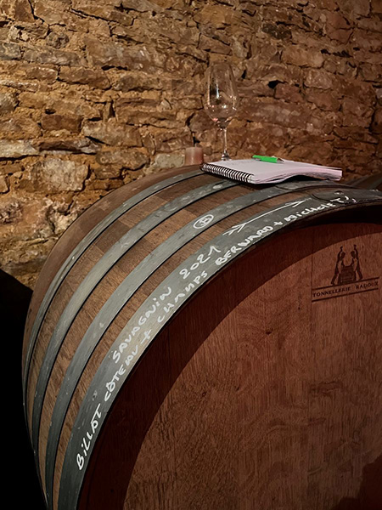*Offline tasting, the way to go*

I have to admit that I enjoyed transcribing my handwritten notes very much. I have to resort to pen and paper at many domaines because tasting and then typing notes into a computer is simply impossible. I believe I have included more information and insight in the producer profiles and the tasting notes than ever. I really enjoyed my time there, and I loved remembering things and anecdotes to include in this article and all the stuff in the database; the tasting notes and producer profiles came up to 33,699 words, the equivalent of 38 pages of Microsoft Word! It was exhausting but really gratifying…

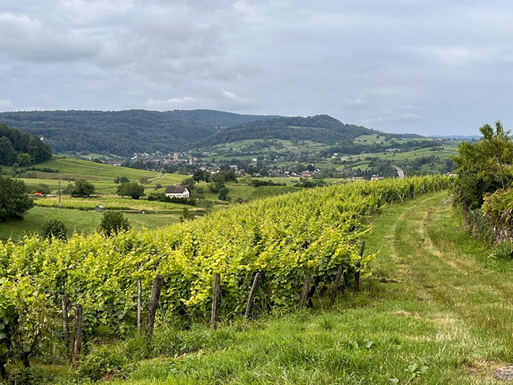

**Ganevatathon!**

On the first day of July 2024, I had a very long tasting at Jean-François “Fanfan” Ganevat's cellars in Rotalier, in the south of the region. But it felt more like autumn than summer, and it rained intermittently, as I saw when moving from one cellar to the next. The tasting always starts with the *négoce* reds from the most recent vintage. It's difficult to know what components will make it into which cuvée, as they are often blends and the components are kept separately. But it's a good opportunity to get a first glimpse of the character of the year; this time, it was clear that the 2023s will be fresher than the 2022s. And as I already mentioned last year, the arrival of winemaker Jocelyn Broncard has resulted in an improvement of the red wines, including the *négoce* ones, which were more hit-and-miss in the past.

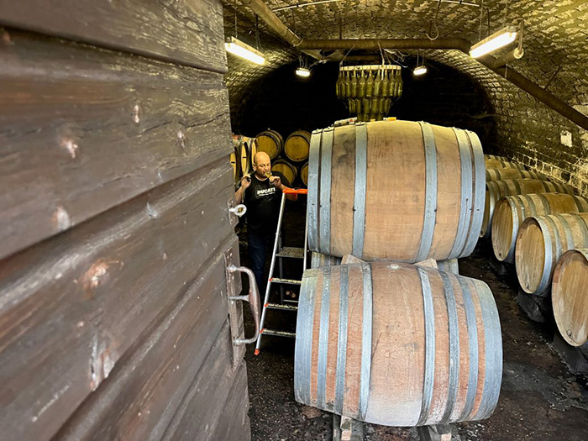*Different cellars, different evolution of the wines*

They explained that since 2021, they have a sorting table and also better conditions in the cellars, even though they installed refrigeration in 2015. The wines are cleaner and have more precision and lower levels of volatility, to which Broncard seems quite sensitive. They cool the grapes all night to eight or nine degrees Celsius, and the fermentation starts slowly and sees a maceration of about four weeks.

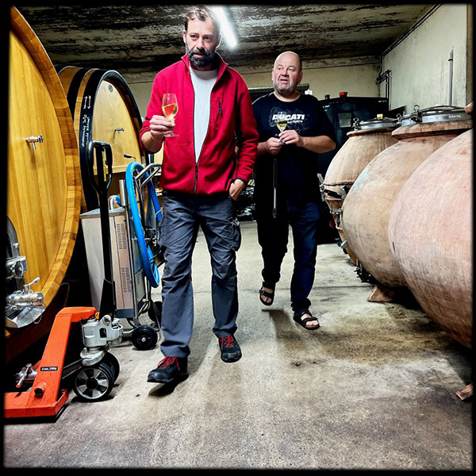*Walking and tasting in the Ganevat cellars with Jocelyn Broncard (left) and Fanfan Ganevat (right)*

I started tasting with Jocelyn, and we were later joined by Fanfan, who was in a very good mood. They expect to start harvesting the 2024 grapes quite late, from mid-September, in a year marked by spring frosts that damaged Chardonnay and the reds especially. They are suffering an end of the season with lots of rain and cooler temperatures, where the main concern is the pressure from mildew. In 2021, they had similar conditions and got laughable yields. And they don't expect to have any red wines in 2024. The long aging means you can compensate the loss and have a better planning of the wines than if you sell them immediately after the harvest.

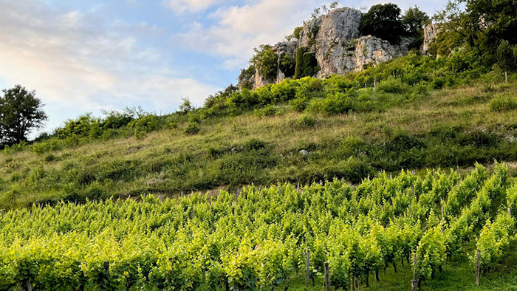*The vineyards below the rock in Rotalier*

There's virtually no wine from 2021; they produced 200 liters per hectare in white and 400 in red. The result is surprisingly good, a vintage like yesteryear, straight, serious, with low alcohol, fresh and mineral. In 2019, they were also hit by frost, and some wines are still in the making. The 2020 whites were still completing their *élevage*, as they now age the whites for at least four years in barrel. The year was warm, for whites almost as warm as 2022, but with the long aging, the wines gain freshness, partially because of the volatile acidity (which is acidity after all) going up and lifting the wines. They compared them to the 2019s, also a warm and ripe year, which they consider perfect for drinking now, but with a little more acidity.

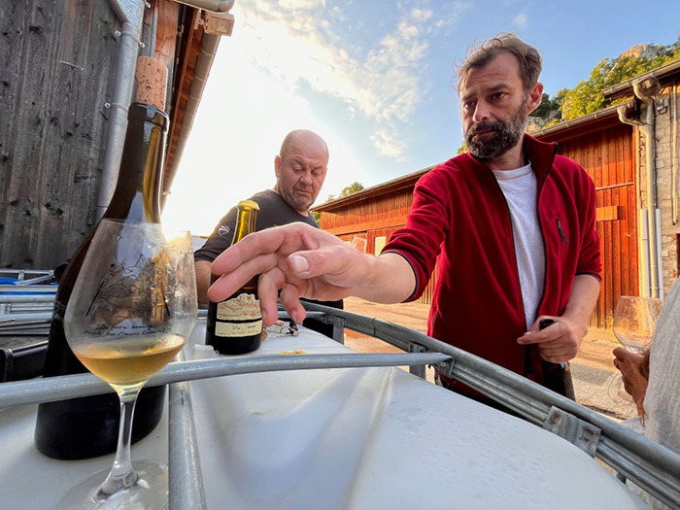*Let’s see the Vin Jaune…*

Each time I visit Ganevat, he surprises me with something different. And it’s not only new wines or old unbottled vintages still in cask; this year, I discovered there are different barrels from Les Vignes de Mon Père aging in different cellars that show very different from each other! And now he tells me that if the wine from Le Champ Bernard, which has been the source of the bottling in the last few years, doesn’t deliver in a given year and they have a nice lot from Marnes Bleues (or from another vineyard!) that has the character and quality, it might be bottled as Les Vignes de Mon Père! So, until the wine is in bottle, we have to take all the information in a relative way, because nobody knows what’s going to happen… The 2014 sample I tasted this time had nothing to do with the one I tasted last year. Last year’s felt oxidative and advanced, and this new one feels a lot fresher…

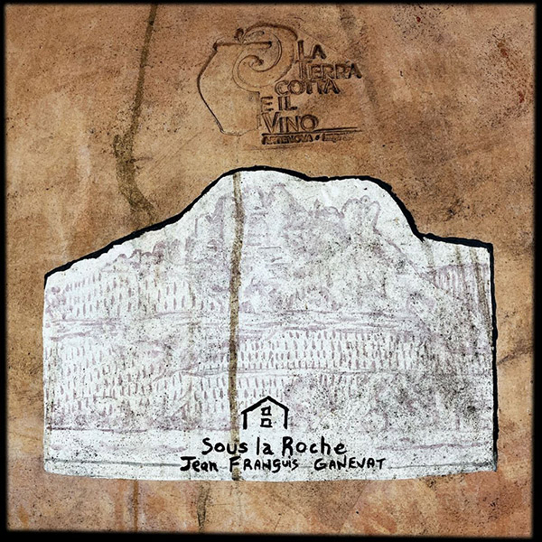*Clay, barrel, foudre…*

Le Champ Bernard is only 30 ares, or 0.3 hectares, a tiny plot. This year I had the time to find the vineyard between the villages of Cesancey and Grusse to see the source of one of my favorite white wines in the world. I found it, and it's very small and not the spectacular vineyard I was expecting, because the wine is truly spectacular but the vineyard doesn’t tell you anything special…

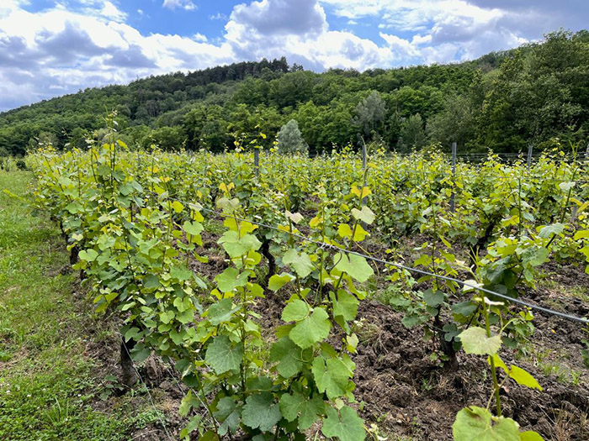*Le Champ Bernard vineyard between the villages of Cesancey and Grusse, the source of one of the finest white wines in the world*

I also taste a lot of wines that nobody knows what they are going to be. This time it was a bunch of skin-contact whites, which is not my favorite style, but they showed very interesting; a 2021 was super exotic and felt like a Riesling, with notes of tangerine and quince. Another sample of skin-contact Savagnin, from vines planted in Les Varrons between 1940 and 1945, revealed more varietal character with notes of peach skin and tangerine with more freshness.

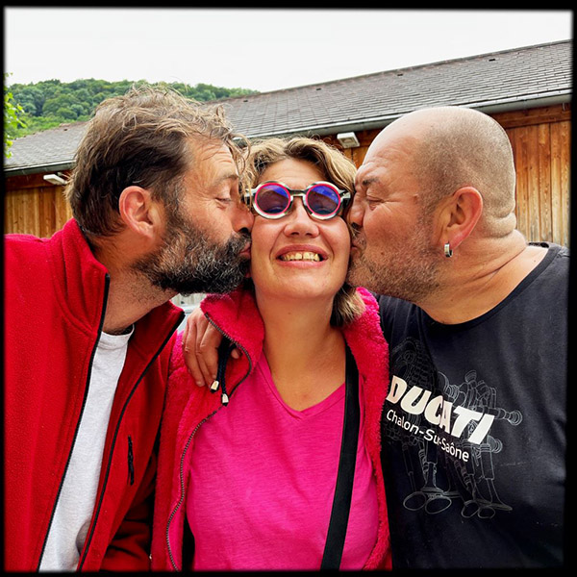*The Ganevat team (left to right), Jocelyn Broncard, Anne Ganevat and Jean-François “Fanfan” Ganevat*

All these skin-contact whites are still in the making, and they have no idea when they are going to be bottled, how many different wines there will be or what names they are going to have… It has to be when they like the wine, and some showed better than others. A third sample had a nice reduction with notes of white flowers and cereals and was lively and fresh but with some notes of cider. Another one had notes of bruised apples and quince and felt medicinal and pungent with some bitterness reminiscent of white chocolate. I tasted Chardonnay, Savagnin and blends from 2018, 2019 and 2021.